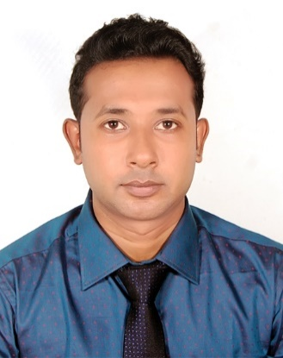**RESUME**

**Asraful Alam**

Address: Vill:Gopalpur,P.O:Hat-Modapur,P.S:khalukhali,

Dist:-Rajbari,

Mobile: 01750-857386

E-mail: **asrafulalam1999@gmail.com**

**Career Objective:**

Toacquires a challenging position in a reputed organization at a leadership role that requires professional, administrative, resource management and analytical skills. To make a significant contribution working as part of a dynamic team, delivering result under pressure and breaking new grounds at national & international level a civil Engineer.

**Academic Qualification:**

|  |  |  |  |  |
| --- | --- | --- | --- | --- |
| Exam title | Concentration | Board/university | Result (%of marks) | passing year |
| B.Sc. in CE | Civil Engineering | Stamford University of Bangladesh | CGPA:3.27(scale:4) | 2017 |
| H.S.C | Science | RajbariGovt College | GPA:3.60(scale:5) | 2012 |
| S.S.C | Science | Gopalpur High School | GPA:4.38(scale:5) | 2009 |

**Field of Expertise**:

Project operation & Management, planning coordination, Feasibility assessment, Estimating & cost analysis, construction development, HR-Payroll.

**Work Experience:**

**ACE Engineering Solution Ltd.**

**Project Engineer**

Project Engineer at **ACE Engineering Solution Ltd. Kolagaon, Baraka Shikalbaha 110MW powerplant, Potia, Chittagong.**

**Computer Skills:**

**ETABS , Auto CAD 2D MS Word, MS Excel, MS Power Point, Internet Browsing and Design Softer-ETABS.**

**Languages Efficiency:**

Both Spoken and Written in English and Bengali.

**Training:**

|  |  |  |  |  |
| --- | --- | --- | --- | --- |
| **Training Title** | **Tropic** | **Institute/ Provided by** | **Duration** | **Year** |
| Thesis | Analysis and design of a twelve storied building with seismic detailing | Stamford University of Bangladesh | Eight month | 2016 |
| Industrial Training | Site Engineer | **Noor Sons Real Estate & Developer Ltd** | One year | 2017 |
| Industrial Training | Project Engineer | **ACE Engineering Solution Ltd** | One year | 2018 |
| Industrial Training | Executive Engineer | **Alfa Engineering & Consultant** | Continue | 2019 |

Personal Details:

Name : Asraful Alam

Father’s Name : Amirul Islam

Mother’s Name : Sum-sunnahar

Date of birth : 30-05-1994

Nationality : Bangladeshi (By Birth)

Religion : Islam (Sunni)

Sex : Male

Marital Status : Unmarried

National ID :19948214760000004

Permanent Address : Vill :-Gopalpur, P.O :-Hat-Modapur, P.S :-khalukhale,Dist:-Rajbari,

Present Address :443/A,PirPaglaLane,Wireless,Railgate,Boro-Moghbazar, Dhaka

**Reference:**

Reference: 01 Reference: 02

|  |  |  |
| --- | --- | --- |
| Ruma Parvin Shilpy |  | Dr. Ali Ahmed  Associate Professor  Department of Civil Engineering  Stamford University Bangladesh  Cell: +8801553308982 |
|  |  | |

**Certification:**

To the best of my knowledge the above-mentioned in formation is true and I am aware about the fact that my misrepresentation of might be treated as disqualification for me.



**Signature**

Date:03-07-2019